**Business Intelligence solution devlopment report**

**MIS271: BUSINESS INTELLIGENCE & DATA WAREHOUSING**

MIS271MI

Table of Contents

1. Introduction 3

2.Data set cleansing and standardisation 4

2.1 Discussion and Justification 4

3. Analysis and reporting 10

3.1 Excel Analysis 10

3.1.1 Product analysis 10

3.1.2 Descriptive analysis 13

3.2 Power BI Analysis Part 1 16

3.2.1 Power BI Analysis Part 2 18

4. Dashboard: Regional manager 21

4.2 DAshboard : Sales manager 25

5. JUSTIFICATIONs AND RECOMMENDATIONs 28

References 32

# 1. Introduction

The purpose of this Business Intelligence report is to decipher insights relating to sales/order trends and customer behaviour for the management team of Superstores, a retail business that specializes in selling products typically found in offices such as furniture, technology, and office supplies. The company is based in the USA and has a notable presence in many of the states within it.

Superstore has provided Group 7, a team of graduate business analysts, with a dataset containing parameters of the many different facets of the business, such as sales/order data and customer information so that the team can analyse the dataset, design BI solutions for managerial use and make a series of justifications and recommendations for the Superstores managers. There are four key sections of the report below: Cleansing and Standardizing the dataset, analysis and reporting using Microsoft Excel and Power BI, dashboard development and our justifications and recommendations for the business.

Firstly, the dataset had to be cleansed before it was used for our analysis. According to **Erhard Rahm and Hong Hai Do (2000)**, the purpose of data cleaning is to detect and remove errors and inconsistencies from the dataset, so that our analysis will not lead to misleading information. The team performed this function on MS Excel before loading the data onto Power BI and significantly improved the dataset’s quality provided by Superstores in the process *(refer to the data cleansing section in our report for further information)*.

Next our team performed an analysis of the dataset using Microsoft Excel and Power BI, by creating visualizations and dashboards. **Dr Shekhar Pawar (2016)** states that the pros of Microsoft Excel include having an ideal interface for making data tables, contains well documented formulas and syntax and is therefore understandable by users in every industry, whereas **Nancy J (2023)** states that one of the main advantages of Power BI is that it enables more effective sharing and collaboration. Furthermore, dashboards, which are a selected group of visuals that can provide quick insight to the data, can be easily created using Power BI *(refer to the Analysis and Dashboard section below for more detail)*.

Lastly, a section dedicated to key justifications and recommendations based on our analysis of the Superstores dataset has been provided so that managers of the Superstores can act on this information to improve the position of the company. This report addresses all four assessment requirements: data cleaning and standardisation, Excel-based analysis, Power BI reporting, dashboard development, and managerial recommendations.

# 2.**Data set cleansing and standardisation**

The dataset had to be cleansed on Microsoft Excel before it was used for our analysis. The purpose of data cleaning is to detect/remove errors and inconsistencies from the dataset, so that its value can be maximized, and so that our analysis will not lead to misleading information **Erhard Rahm and Hong Hai Do (2000)**. The team performed this function before loading the data onto Power BI and improved the quality of the dataset initially provided by Superstores.

## 2.1 **Discussion and Justification**

**2.1.1 Converting data into a Table**

**Figure 1- Converting Superstores Dataset into a Table.**

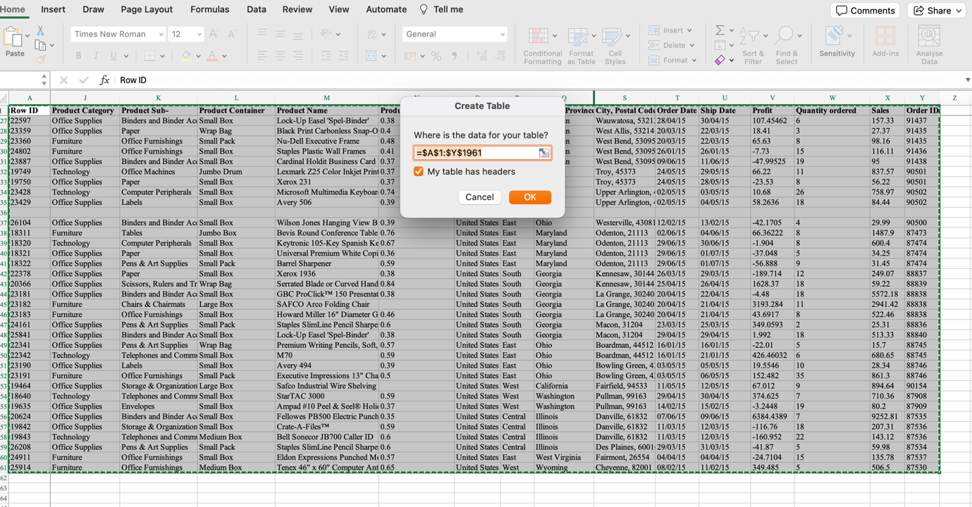

According to **Muhammad Sheheryar (2023),** table formatting in Excel makes it easier to manage large sets of data. Excel automatically applies formatting features to the table **(Figure-1),** this structured format enhances the visual clarity of the dataset, facilitating quick identification of trends, patterns, and outliers. This method streamlines the analysis and optimize consistency when imported to PowerBI.

**2.1.2 Removing hidden rows and columns**

**Figure 2- Removing hidden rows in the dataset.**

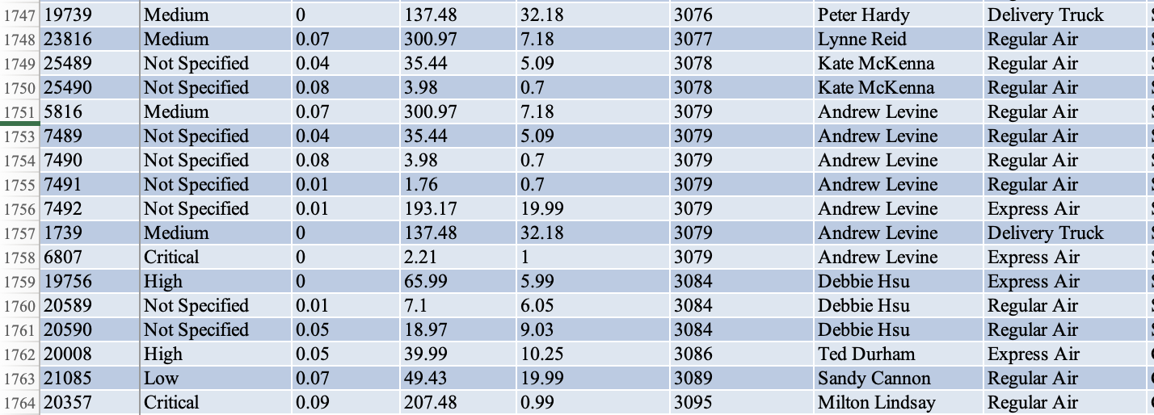



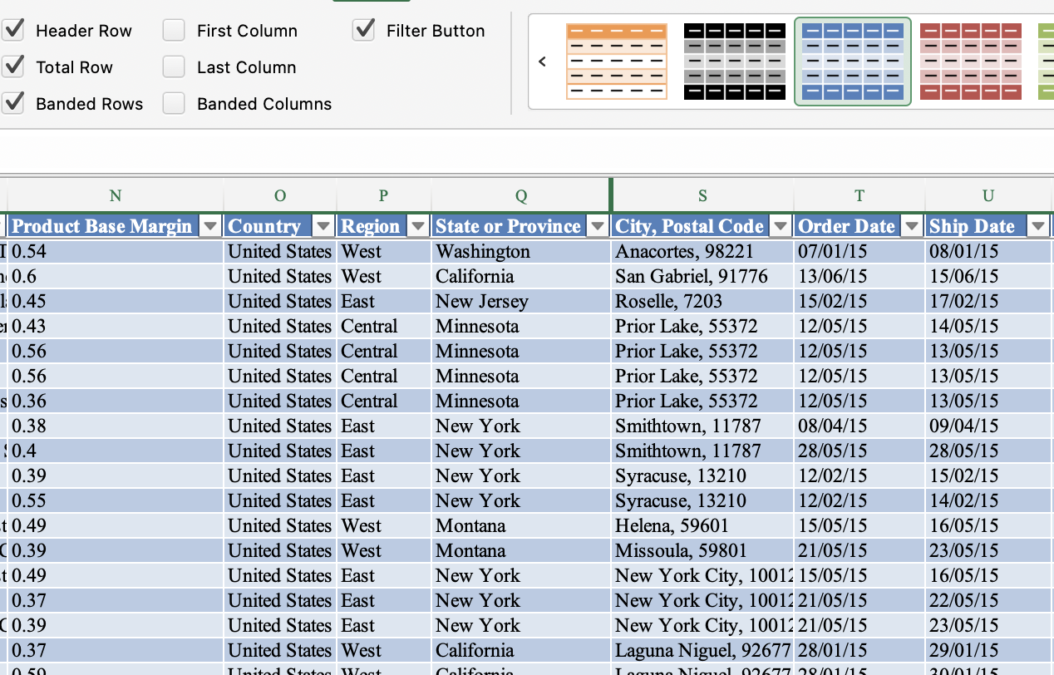



**Figure 3- Removing hidden columns in the dataset.**

The dataset was then scanned to detect any empty columns or rows, and these were then unhidden. These blank columns/rows added no value and disrupted the dataset’s integrity, and hence were removed. One hidden Row **(Figure 2**) as well as One hidden column **(Figure-3)**were found in the dataset and were then removed.

**2.1.3 Deleting empty rows.**

**Figure 4- Deleting empty rows in the dataset.**

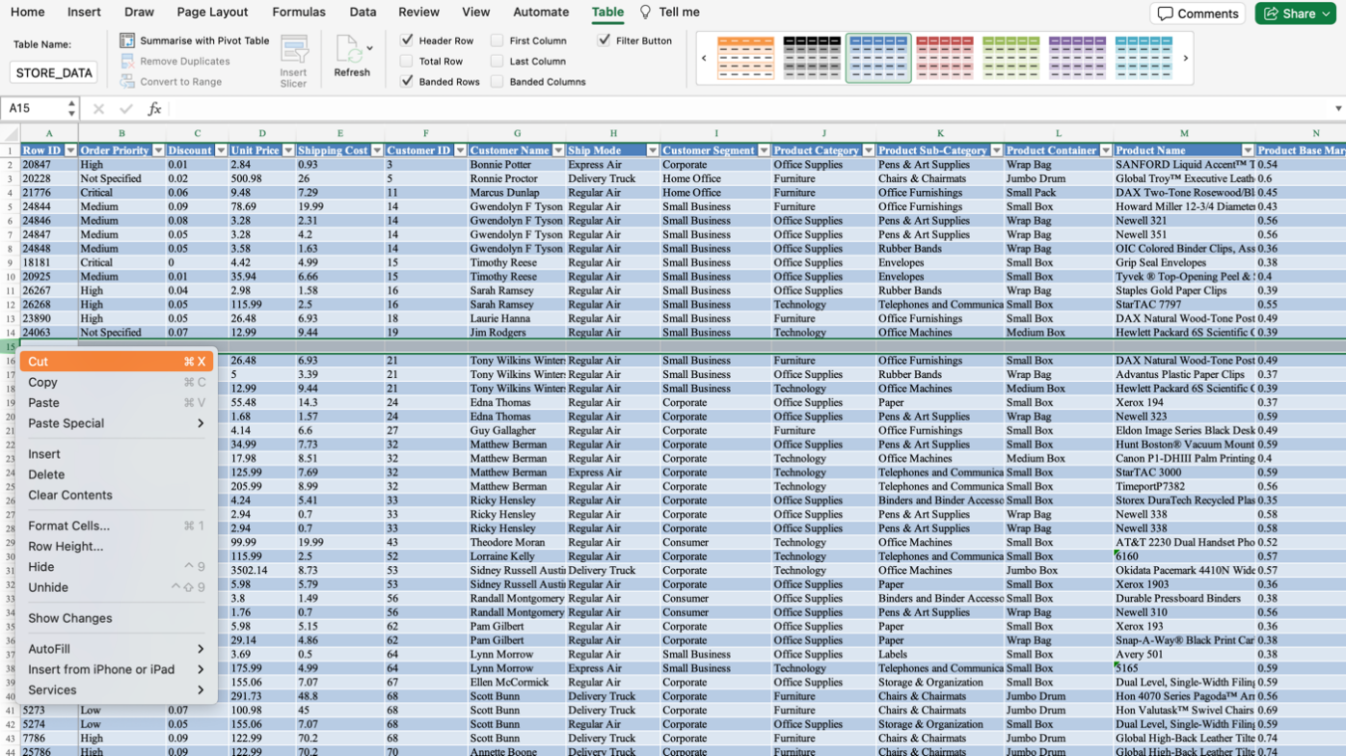

Some rows in the dataset were not hidden but were simply empty. Similarly, these empty rows **(Figure-4)**added no value to the dataset and had to be deleted. Some of the techniques like forward fill, average analysis or Meta data referencing can be helpful in filling these empty rows but they are only effective if a certain column is empty, and since there were no existing data points empty, we decided to remove them to maintain the quality of the dataset.

**2.1.4 Removing duplicate data.**

**Figure 5- Removing Duplicate Values from the Dataset.**

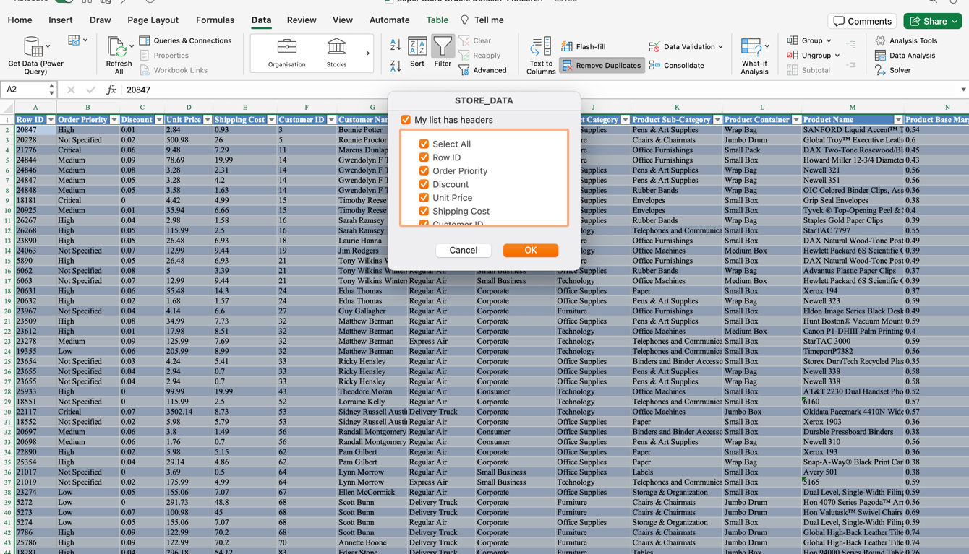

Identifying and removing duplicates from the dataset is an essential to maintain the quality, reliability, and accuracy of the analysis. Failure to address duplicates can cause errors in analysis. To subtract the risk, we utilised the **‘Remove Duplicates’** feature of Ms Excel **(Figure-5).**

Our approach was to remove the duplicates based on unique keys like Customer ID or Order ID assuming they will be unique. Digging deep into the data we got to know that these unique identifiers are duplicates so we decided to remove the rows which are fully duplicated from every column. We found out that 4 rows were completely duplicated.

**2.1.5 Separating city and postal codes**

**Figure 6- Separating City and Postal Codes using Text To Columns**.

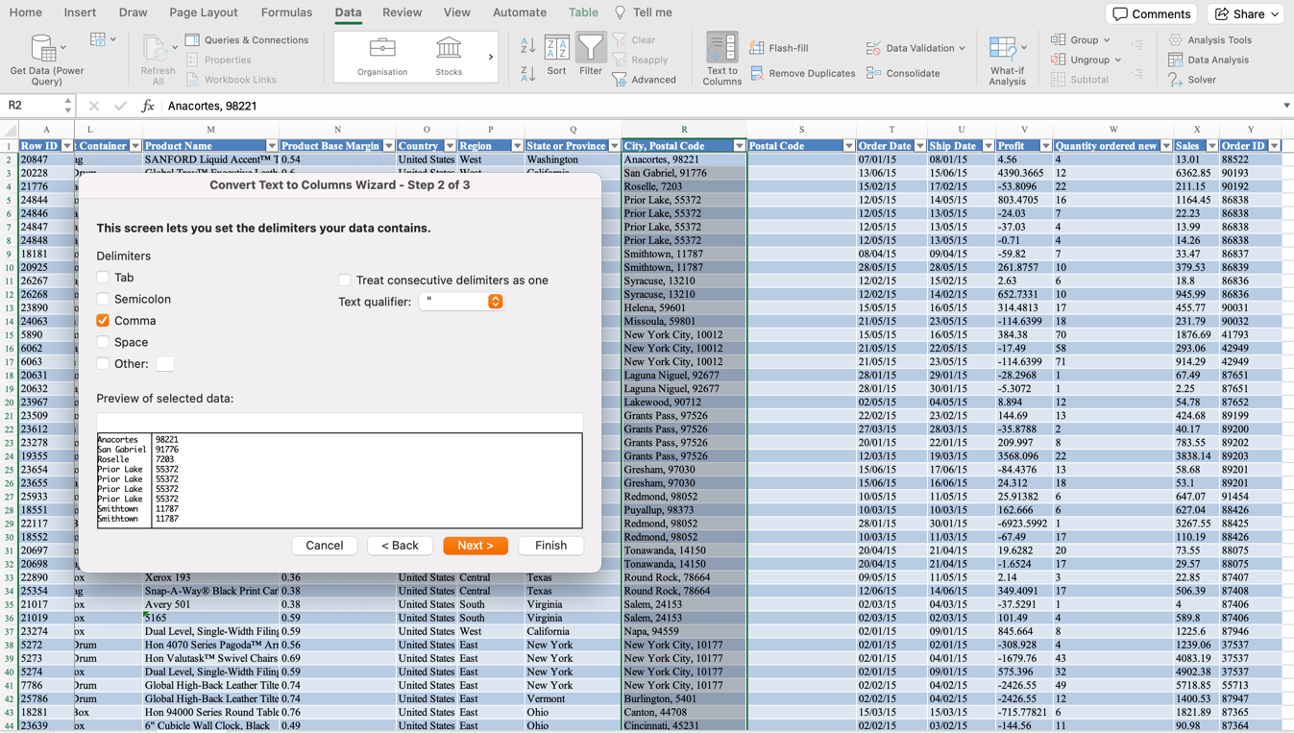

In this instance we encountered a scenario that one column contained overwhelming amount of information. The column had a combination of both cities and postal code values, so we had to separate these values into different columns. To achieve this, we used an excel feature called **“Text to Columns”** **(Figure – 6).** This feature helped us separate the values using commas and this improved the readability and structure of the dataset.

**2.1.6 Standardization by adding Dollar signs**

**Figure 7- Adding Dollar signs on Excel.**

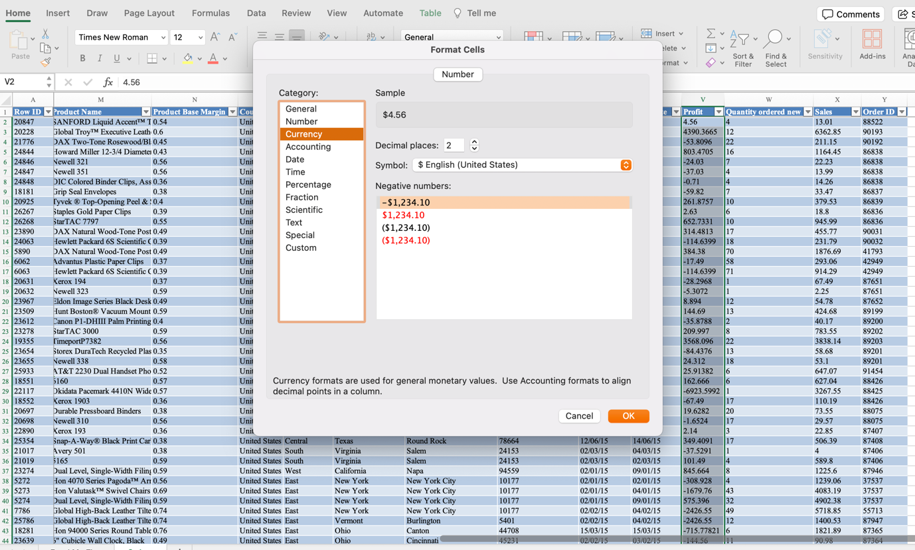

As some of the columns having numbers and currencies in the dataset did not have the sign assigned to them so we took the initiative to enhance the readability and scalability of the dataset. Since the store dataset was of USA, It was assumed all the transactions were done in USD so with the help of ‘Format Cells’ feature we added a dollar sign to standardize the columns and get them onto same scale **(Figure – 7**).

This practice aligns with presentation of the dataset for the stakeholders and such attention to detail reflects commitment towards extracting meaningful insights

**2.1.7 Deleting the Product Base Margin Column**

**Figure 8- Deleting the Product Margin Column.**

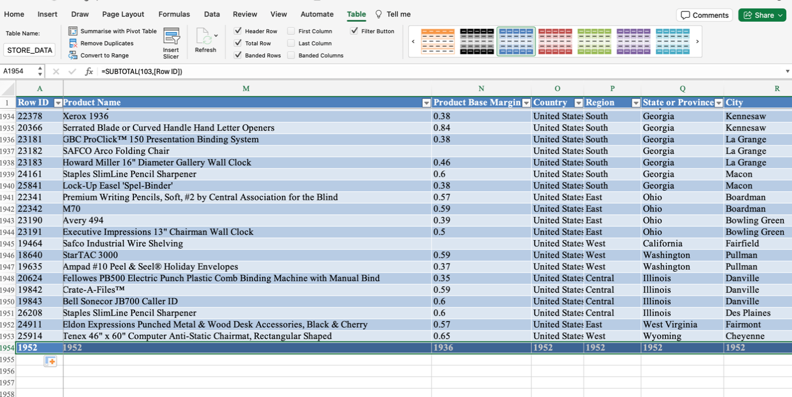

Our team meticulously scrutinized the dataset and identified 16 scattered blank entries within a Profit base margin column **(Figure – 8)**. Furthermore, as this column was not defined in the Read Me section accompanying the dataset, its relevance and significance was unclear. Given the absence of documentation and the presence of missing values, the column was excluded from downstream analysis to prevent misinterpretation. By removing this column, we further polished the dataset before importing the dataset into Power BI.

# 3. **Analysis and reporting**

## 3.1 Excel Analysis

By using Microsoft Excel, the dataset was analysed, and key findings were presented. Main analysis was done on several variables like Mode of transport, Products, Product Category, Profits etc. Our analysis provided a valuable insight into various aspects of business operations.

This section focuses on product-level performance to distinguish between high-revenue and high-volume items

### 3.1.1 Product analysis

**Figure 9- The Top 5 most sold products.**

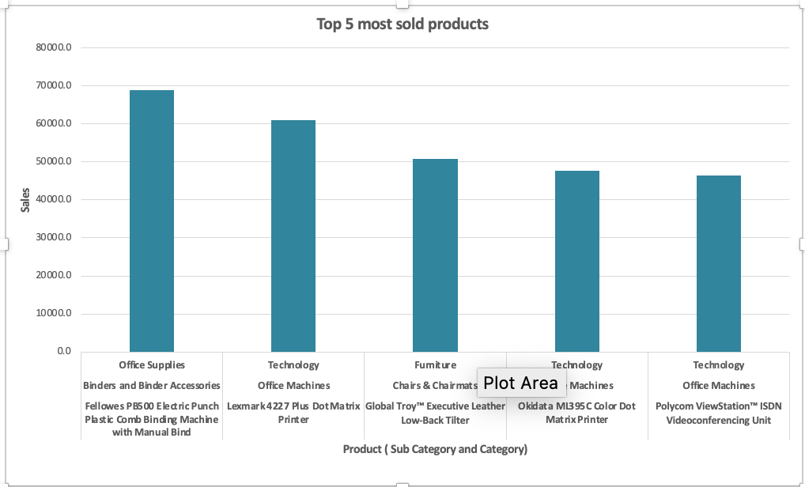

According to our findings, topmost **(Figure 9)** product that generated most sales was **Fellowes** **PB5 00 Electric Punch Binder** which made total sale of $69,000 dollars followed by **Lexmark 4227 plus** which generated $61,000 in sales and **Global Troy Leather chair** at $50,000. Here Polycom View Station™ ISDN Video conferencing Unit is the most expensive product which is sold at $6,783. These are the products which generated most of the sales, and in addition to being significant revenue generators, also provided valuable insights into consumer preferences and market trends. It should be noted that though these products initiated good chunk of sales, they were not the most ordered products.

**Figure 10- The Top 5 most ordered products.**

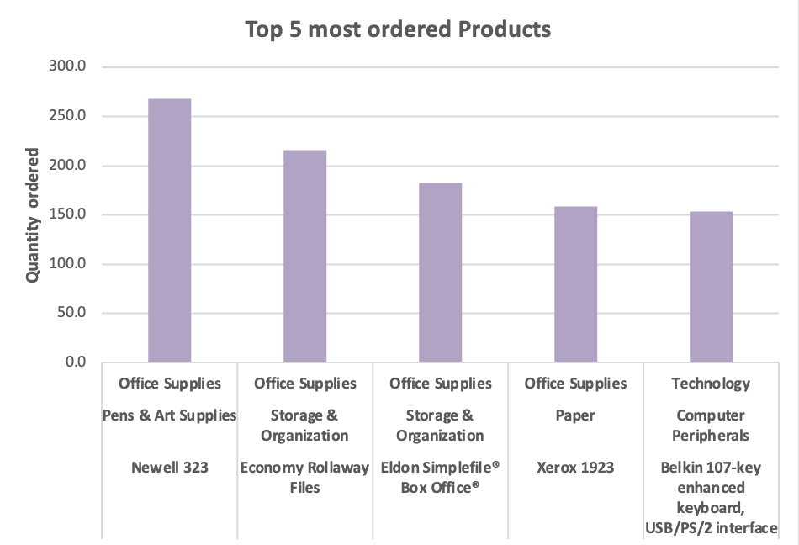

The most ordered product **(Figure 10)** was **Newell 323** where 268 quantities were ordered, which are pens and sharpies stating they have a good market hold with high demand. The second most ordered item was Economy rollaway files where 216 quantities were ordered in first half of the year (Jan – June) etc. The least ordered item was Belkin 107 Key enhanced keyboard, which is a technological item. This tells us that most ordered Product category was Office supplies whereas Technological products generated the most revenue.

**Figure 11- The Profit of Product Categories by Region.**

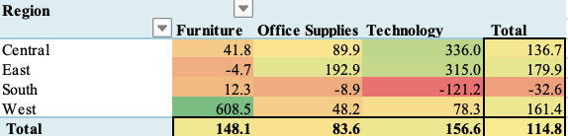

**(Figure-11)** Digging deeper in the analysis, we gathered the insight that different product categories are more profitable than the other in different regions. Breaking down the findings, we discovered that the average profit of Furniture is $148.1, and that furniture is most profitable in **Western regions** where the average profit was $608 and is least profitable in Eastern regions where it generated negative profit. Furniture was also not that profitable in the southern region in comparison to the Northern region. In our next product category, we can see that Office supplies was overall the least profitable category presenting a consistent challenge across all regions.

Office supplies generated the most profit in the Eastern region where the average profit was $192.90 and is the least profitable in Southern region where it generated negative profit. Office supplies performed very well in the Central region, given that unit price of Office Supplies is the lowest among other categories.

Lastly, the most profitable items in the Central and Eastern regions were Technological products, generating an average profit of $336 and $315 respectively. Southern region saw a major tech letdown, with technological products disappointing customers and leading to negative returns of -$121 on average.

Even with that negative return, technological products have highest average product profits among other categories given that they are most expensive products. Our analysis on regional profitability revealed that the Eastern region is most profitable, while the Southern region lagged and experienced negative average profits.

### 3.1.2 Descriptive analysis

Beyond product-level performance, state-level profitability was analysed to identify geographic patterns.

**Figure 12- The Top 5 Most and Least Profitable States.**

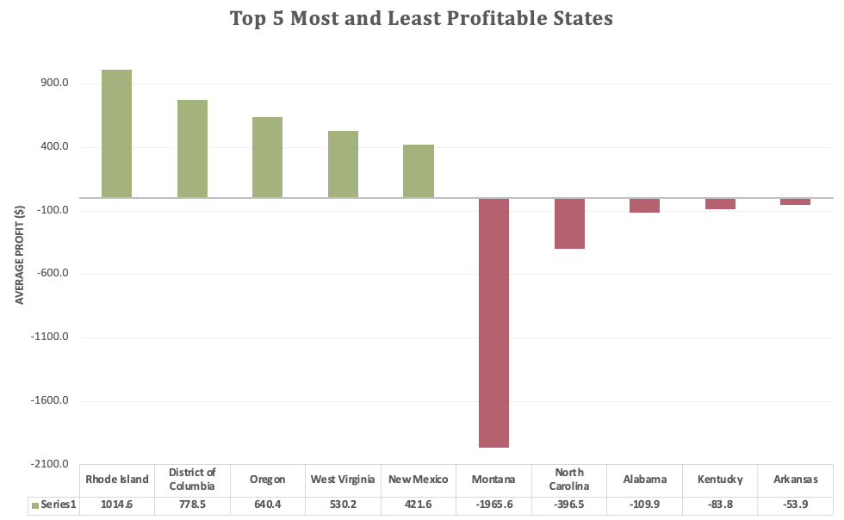

In general, the profitability of different products can vary significantly across different regions. Understanding which states are most and least profitable for the business is crucial when developing strategies to optimize the business's profits.

**(Figure 12)** depicts the most and least profitable states. **Rhode islands** emerged as most profitable state for the business, returning an average profit of $1014 per sale whereas **Montana** presented a significant challenge with major negative returns of - $1956 per sale.

Other profitable states were the districts of Columbia, Oregon, West Virginia and New Mexico, These states enjoyed a healthy range of average profits between $420 - $790 per sale. The least profitable states besides Montana were North Carolina, Alabama, Kentucky, and Arkansas where they returned a range of negative profits dipping between - $52 and -$397.

Beyond Montana’s substantial losses, Oregon was the most profitable state in the western region, whereas central and southern regions struggled with profitability which ignites the necessity of a deeper investigation into why this could be the case.

##### 3.1.3 seasonal Trends and profits

Finally, temporal patterns were examined to understand seasonal fluctuations in sales and profit.

**Figure 13- Average Monthly Sales of Superstores.**

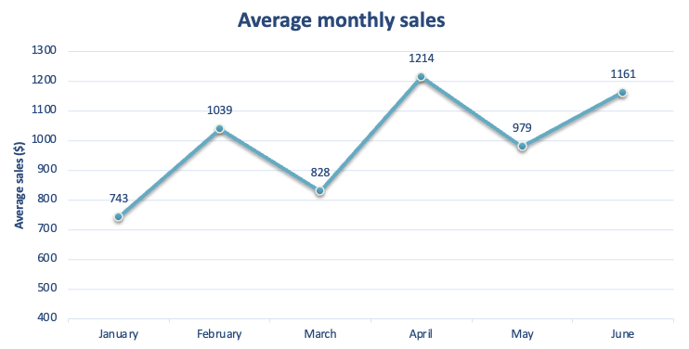

**Figure 14- Average Monthly Profit of Superstores**

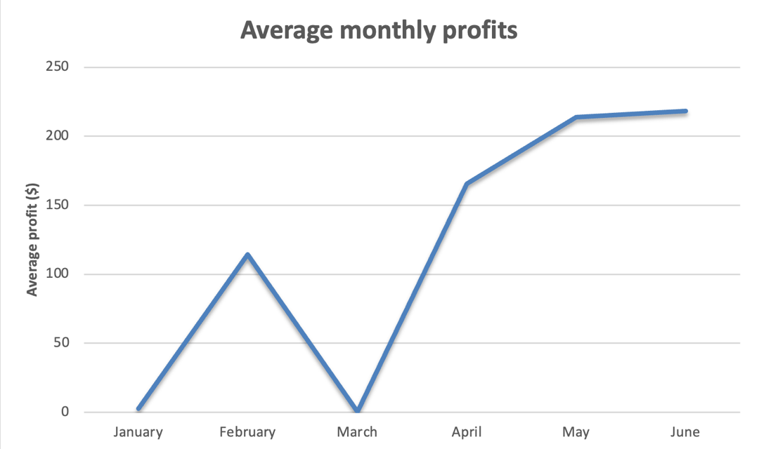

Understanding how sales and profits fluctuate throughout the year is crucial for any business dealing with wide range of products. Even though we have data for the first half of the year, this analysis delves into monthly trends, uncovering insights into average sales by month and average monthly profits.

By exploring these patterns, we can gain valuable knowledge about consumer behaviour, profitability cycles and make informed decisions for the next half of the year.

For the first half-year of sales in **(Figure 13),** we can see that it has a mixed trend with some peaks and trenches, which shows the unpredictable nature of the sales in the first half of the year. In the first half of the year, the average sales were $994.

Though, the first month yielded the lowest sales (only $743), the intriguing part is that most orders were made in January in comparison to the subsequent five months and made up a total of 370 unique orders. February presented positive contrast, boasting average sales of $1039, however the month of March witnessed a sudden drop to $828.

April was a strong month where it had staggering average sales of $1214 followed by a drop and a hike again. The trends in average sales can be due to factors like price per unit and units ordered. In comparison, if we dig deeper and compare the average profit generated monthly, we can see patterns that warrant further investigations. In **(Figure 14)** we can see that despite January’s lowest average sales the profits were not negative which is a good sign.

In February, high sales are accompanied by high average profit at $114, with a drop in momentum in March, where it yielded no profits. Following this, a positive trend emerges in April with both sales and profit increasing steadily. The fascinating part lies in the last two months, despite May having lower overall sales compared to April and June, May delivered equally impressive profits. This could be merely because products with larger profit margins were ordered in this month.

In June, the key insight is that Superstores received the least orders of only 306 but generated high sales and high profits. Understanding the factors behind this success and unpacking the product demands will enable Superstores to perform consistently well throughout the entire year.

# 3.2 **Power BI Analysis Part 1**

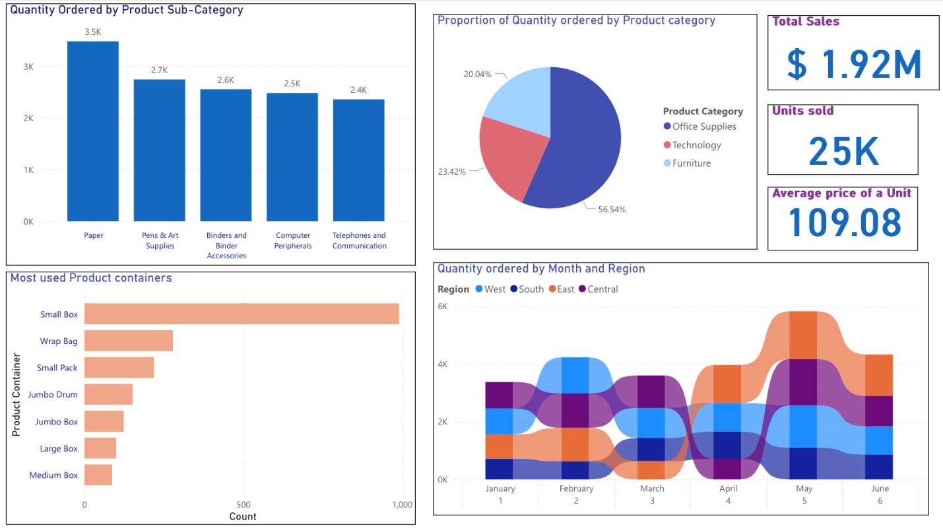

**Figure 15- General Report 1 on Power BI.**

Our first Power BI report **(Figure 15)** is designed to provide key insights on the quantity of items ordered, with respect to product categories, sub-categories and month using descriptive analysis . Using visualizations, intuitive dashboards, and in-depth analytics, we aim to provide Superstores with meaningful insights needed to make informed decisions.

The exceptional performance with regards to sales and the product quantities sold highlights the company's ability to adapt and thrive in dynamic market environments. Superstores performed well in the first half of the year, as total sales reached $1.92 million and 25k units were sold, where average price per unit was $109, which indicated a balanced spread in price across the products sold.

**The first graph** (*Quantity ordered by product sub-category*) shows that the highest ordered product sub-category is Paper with 3.5k orders, followed by Pens & Art supplies with 2.7k orders, which implies that the company’s most ordered sub-categories are office supplies and stationary products. This claim is further substantiated by the **second graph (***proportion of quantity ordered by product category***)**, as 56.5% of the products ordered were office supplies, which emphasises the strong demand of office-related products and the potential monopoly the company may have in this product category.

**In the third graph** (*Most used product containers*), we’ve uncovered that Superstores more commonly uses small boxes or Wrap bags for delivery, which would indicate that Superstores prioritises cost efficiency through conserving resources and contribute to environment sustainability in the process. This may lead to forming positive relationships with stakeholders and foster long-term success for the company.

**Lastly, the final graph** (*quantity ordered by month and region*) above showcases some unexpected fluctuations in the quantity ordered by region in the first six months. We have observed significant variations in order volumes across the North, South, East and West. In January, the quantity ordered across all 4 regions was balanced, whereas in February, this order dynamic shifted, and most orders came from western regions. In March, we can see that most orders came from the Central region, followed by West, South and East. In April, we can see a significant drop in orders, as the most orders came from East region and the least orders came from Central region.

A key insight here is that the East region’s quantity ordered rises across April , May and June and maintains this momentum, whereas the central region experiences a significant drop in the quantity ordered in April, which raises the need for further enquiries.

# 3.2.1 Power BI Analysis Part 2

**Figure 16- General Report 2 on Power BI.**

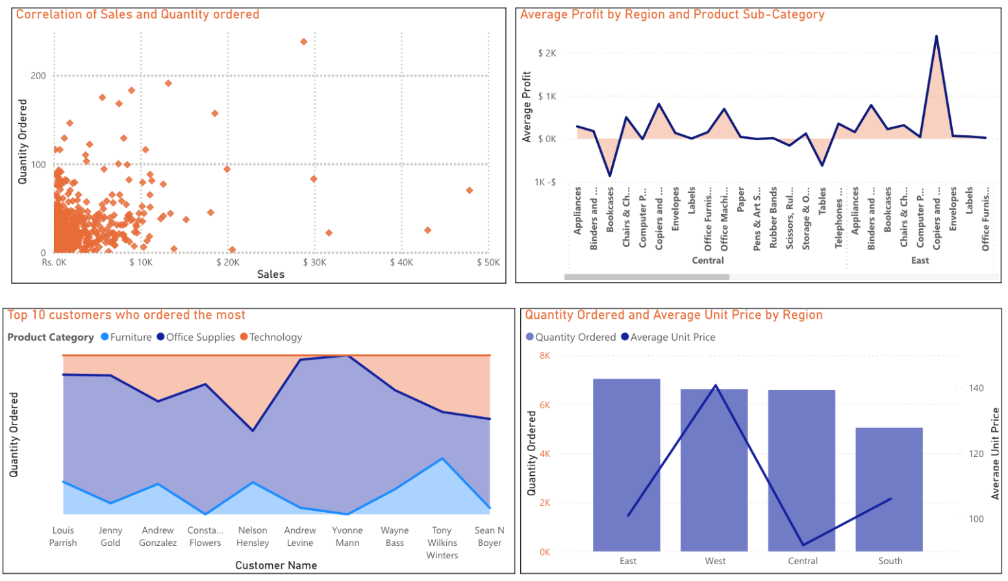

In the second Power BI report(Figure: - 16), our team performed a deeper analysis to extract insights using more advanced statistical methods, by showcasing new findings by utilizing correlation and higher dimensional data analysis.

The first graph ***(****Correlation of sales and quantity ordered****)***shows the correlation between the quantity ordered and sales, across all the products sold during the period. The **correlation coefficient** is 0.34 *(calculated in Ms Excel),* which indicates that there is a weak positive relationship, meaning that there is a slight tendency for higher quantities of products ordered to generate larger sales. This is questionable, as it suggests that aggregate correlation masks heterogeneity across product categories, indicating that category-level or price-adjusted models would provide more reliable insight. Our basic intuition suggests that higher quantities ordered would naturally lead to higher sales. This highlights the importance of controlling for unit price, discounting, and product mix when interpreting aggregate correlations

**Figure: - 18-i**

Though another factor to look for here is that greater discounts could lead to less sales, even when large quantities of products are ordered. The factor could play a role in affecting the correlation coefficient, which may further raise the need for a deeper analysis, where the Correlation Coefficient is segmented monthly.

The second graph ***(****Average Profit by region and product sub – category****)***provides insights on what sub-category of products are profitable in each region. In the Central region, bookcases and tables are least profitable whereas copiers, fax and office machines are most profitable. In the eastern region, we can see that bookcases and copiers & fax are most profitable whereas tables yielded negative profits in this region.

The third graph ***(****Top 10 customers who ordered the most****)*** shows the top 10 customers and their preferred product categories.

**Figure: - 16-i**

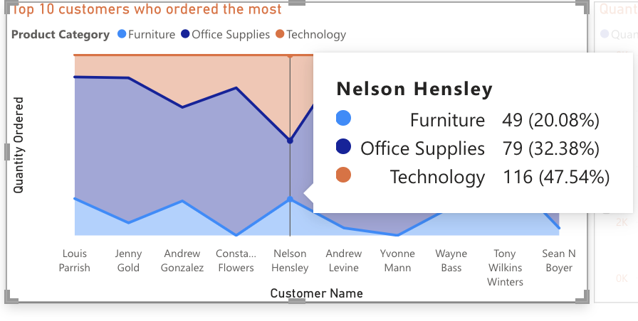

**(Figure 16-i)** shows us that customer *Nelson Hensley* ordered 49 Furniture, 79 office Supplies and 116 technological products across the period, which indicates that this customer is primary interested in Superstore’s technological products. This graph can help us in determining the customer’s ordering patterns to perform targeted marketing, which can eventually yield more profit.

The last graph ***(****Quantity ordered and average price of the unit by regions****)***shows the relationship between the Quantity ordered and the average price of the unit. In the eastern region, the average unit price is $100.93 and 7031 products were ordered, causing the total spending in the eastern region to be approx. $710,970.83. The quantity ordered here is high despite a lower average unit price. This suggests that customers are purchasing products that are perceived to offer good value for money, leading to an increased demand of the product.

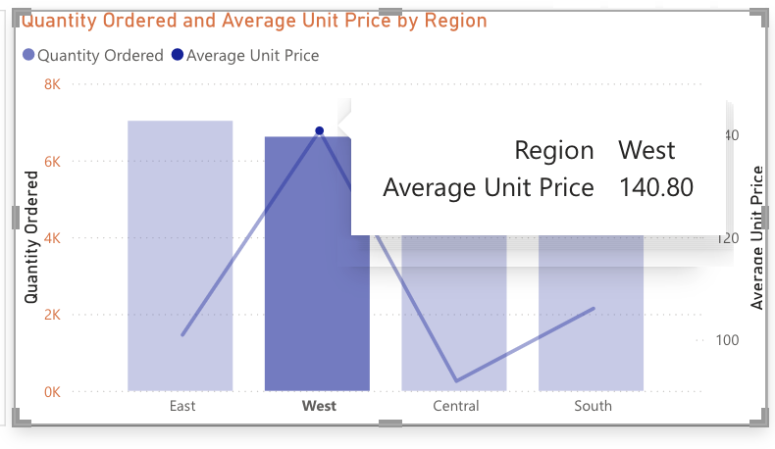

**Figure: - 16- ii**

In contrast, for customers in western region **(Figure:- 16- ii)** the average unit price of products purchased was $140.80 and 6617 products were ordered, causing the total spending in the western region to be approx. $931,673.6. This could suggest that customers are willing to pay more for products with a higher perceived quality, unique features, or a good brand image. It also should be noted that on average the southern region generated the least profit.

##### Assumptions :-

##### The drill down features in the chart sub sections can be done for other components of the chart as well, but not all parts can be explained in the report.

##### In last section, discounts have not been included to avoid financial misinterpretation.

##### It is assumed that the shipping cost is incurred by the company, not the customer. Since we don’t have any metric regarding customer satisfaction relating to the delivery time, we assumed all orders were successfully delivered.

##### Not all our analysis in Power BI can be explained due to the word limit of the report, but the most important findings have still been included in it.

# **4. Dashboard: Regional manager**

**Figure 17- Regional dashboard**

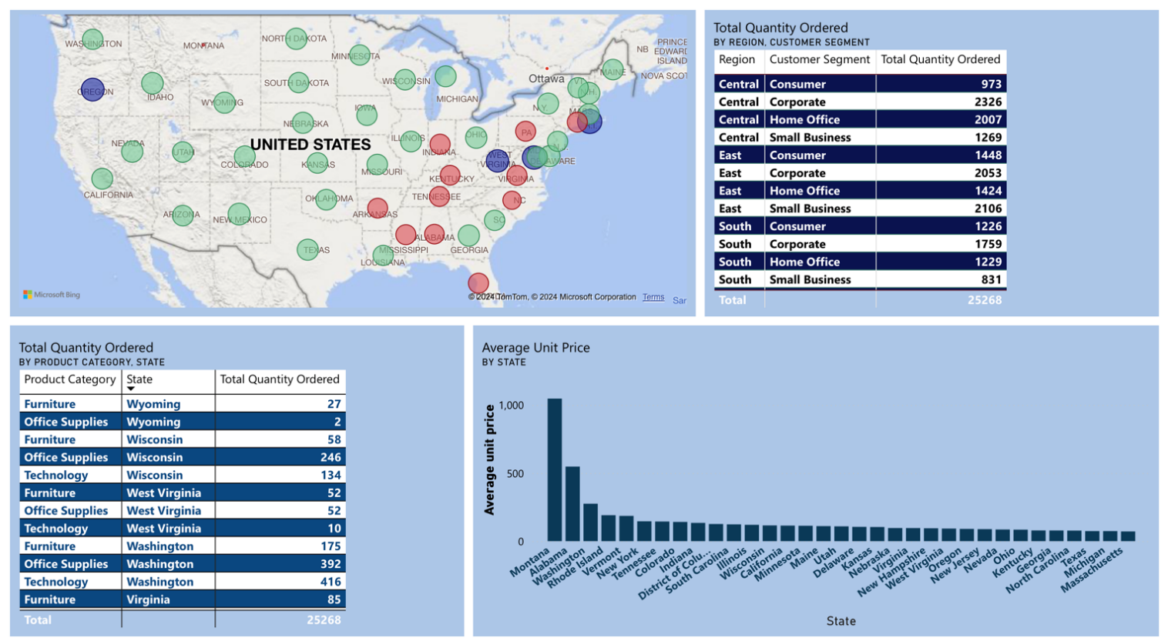

A dashboard was created that summarizes all our key findings for the Regional manager. We made four different charts including variables such as quantity ordered , profit and average unit price in different regions, allowing us to make strategic insights that can enhance Superstore’s **regional performance** and help it achieve organizational goals.

**Figure: - 17-i**

**Figure: - 19- i**

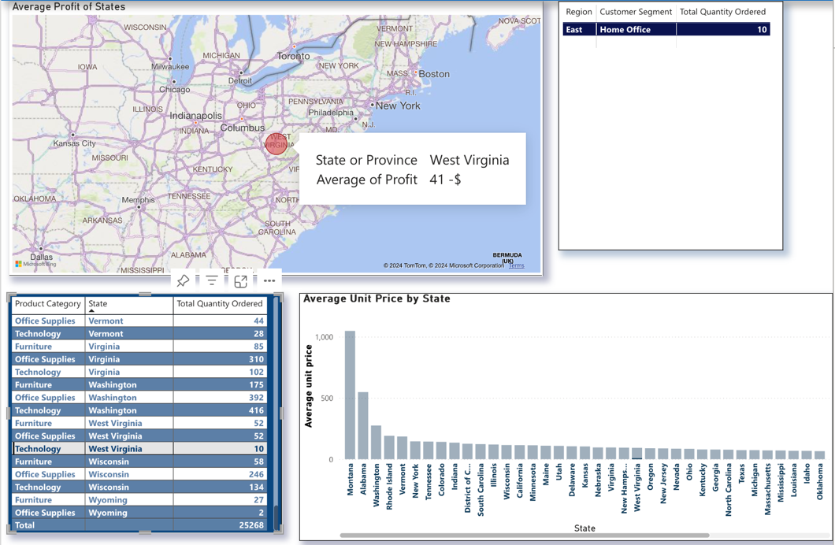

The bubble map provides us with an interactive visualization of the profit distribution of each state by representing profit levels. Through varying bubble sizes and colours, this map offers a clear and intuitive way to discern profitable regions from those with lower profitability . The information on the map can be isolated with the use of tables to give us deeper insights of the profit distribution. If we integrate the table *(Total quantity ordered by product category)* we found that some regions may be overall profitable, but some states don’t perform well in certain categories. In our bubble map, West Virginia’s average profit is $530 but if we dig deeper, we can see that in (Figure: - 17-i) technological products are not profitable in West Virginia with negative profits. This insight underscores the importance of conducting granular analysis to uncover nuanced patterns and trends that may not be immediately apparent from generalised summaries. The table *(Total quantity ordered by customer segment)* also tells us that 10 orders done by Home office yielded negative profits. One of the reasons could be that technological products are expensive products that when ordered more, will eventually be more profitable.

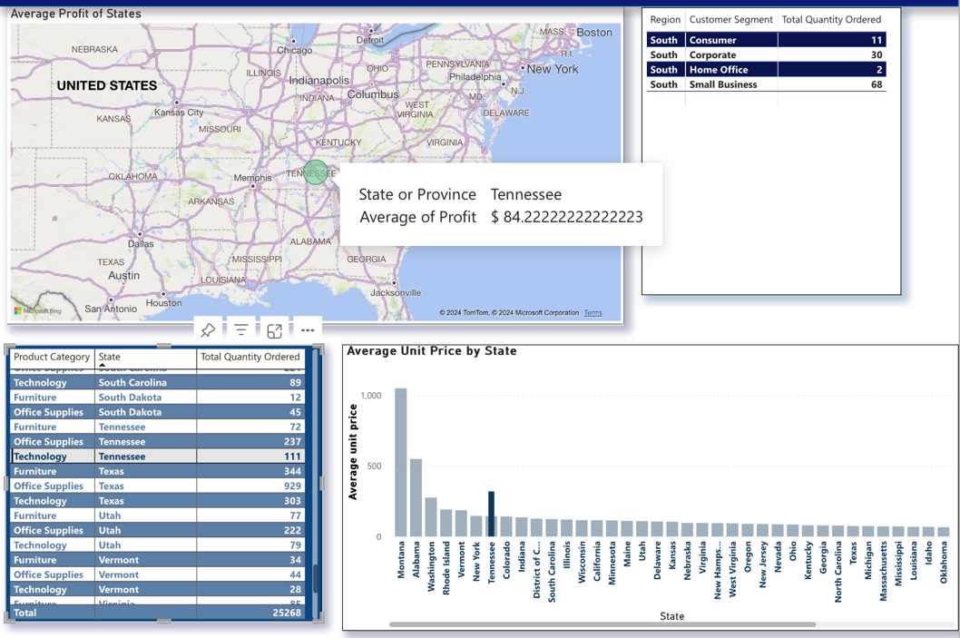

**Figure: - 17-ii**

In contrast, in the state of Tennessee, average profits are shown to be - $39 on average which may be considered as an unprofitable, however if we look deeper into (Figure: - 17-ii) it’s found that Tennessee only yielded positive returns on technological products and has an average profit of $84 dollars, where 111 quantities were ordered in which 68 of these orders were made by small businesses. Our bottom graph also shows us the average unit price was $318.46, whereas overall average price was $144.37.

**Figure: - 17-iii**

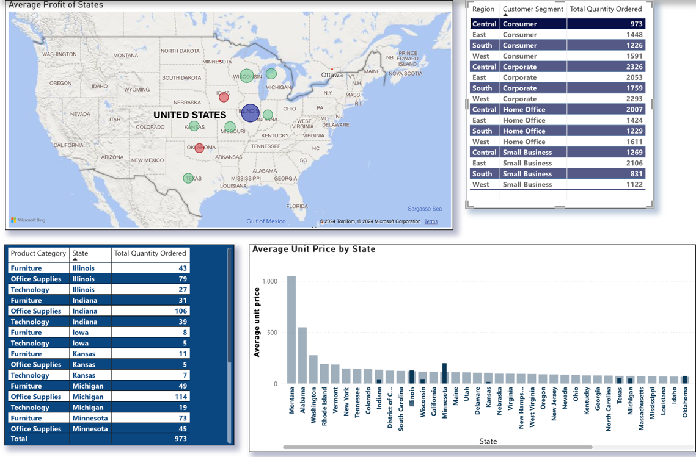

By incorporating the table *(Total quantity ordered by customer segment)* we found that certain customer segments are more profitable in different regions. For instance, (Figure 17-iii) in the central region, the consumer customer segment that is the most profitable is the state of Illinois and the least profitable is the state of Oklahoma.

**Figure: - 17-iv**

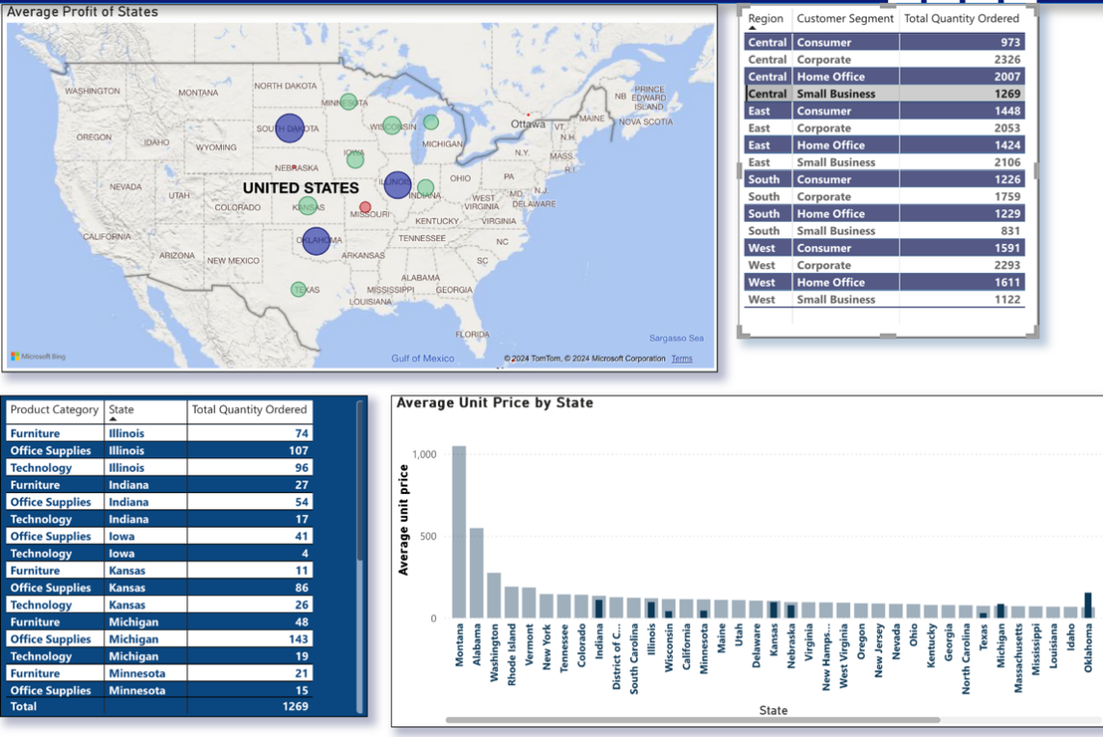

In the central region, the most profitable customer segment was small businesses where most states returned positive profits (Figure: - 17-iv). By drilling down into specific product categories and customer segments, we can uncover hidden opportunities, mitigate risks, and make informed decisions that will ultimately contribute to achieving sustainable levels of profitability and success in different regions in the US.

# 4.2 DAshboard : Sales manager

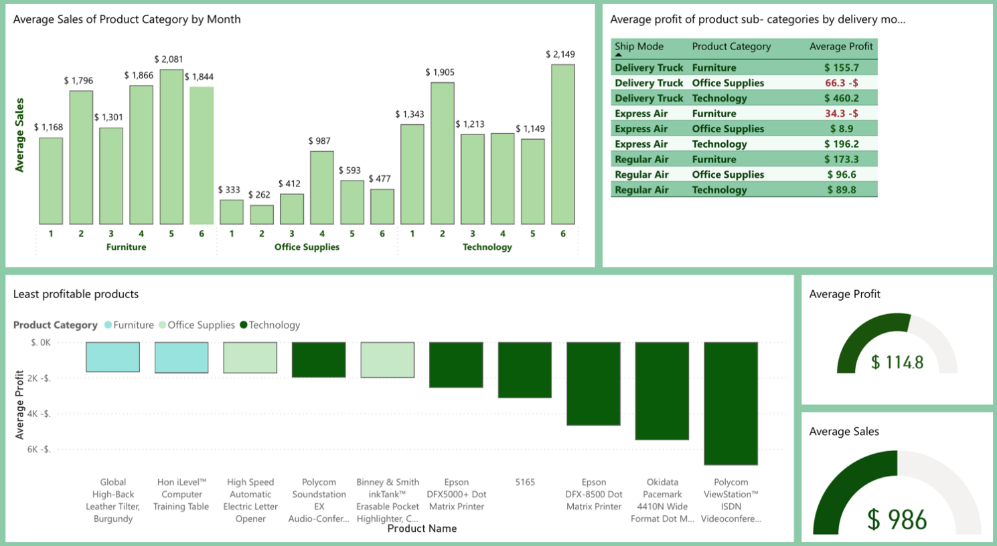

**Figure 18- Sales Manager Dashboard**

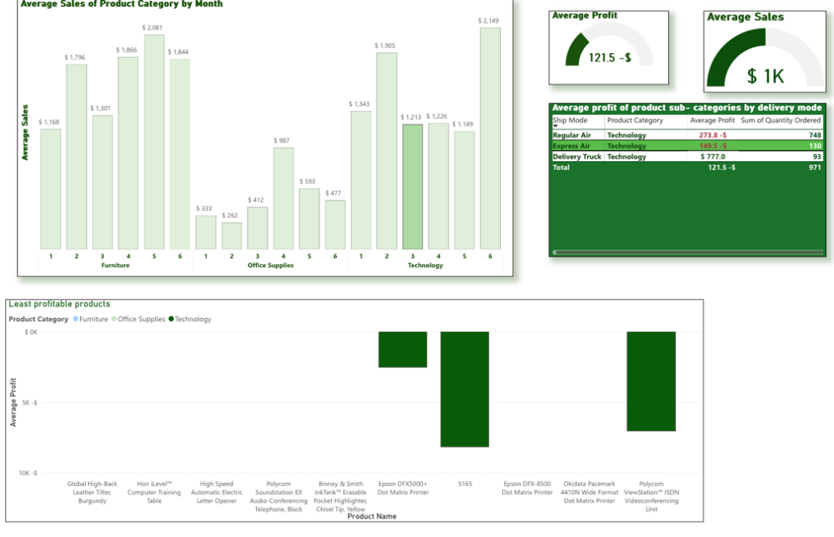

**Figure: - 18-ii**

**(Figure- 18)-** This dashboard (targeted to the sales manager) covers average profits , sale of products , mode of shipment , product- categories and sub-categories to help optimise financial performance and enable data driven decision-making within the company. Across the six-month time, Superstores achieved an average sales figure of $986. During this period, the company managed to generate an average profit of $114.8

Our first graph shows us the average monthly sales of different product categories. We can see that the average sales of Furniture were highest in May and lowest in January. Office supplies had an overall low average sales compared to other two categories, but that’s because of its low unit prices. There was a notable hike in the sale of Office related products in April, whereas in February the average sales were the lowest (only $262). Since technological products have higher average unit prices, June was the most profitable in terms of sales, when factoring in all product categories. After incorporating it with other graphs **(Figure: - 18),** we found that in the month of March technological products delivered by Regular or Express air returned negative profits even though the quantity ordered was very high, 748 & 130 respectively. This could be due to higher shipping costs compared to selling price as well as extensive discounts, which resulted in low profit margins. Three of the least profitable products being sold in these months may have also influenced this outcome.

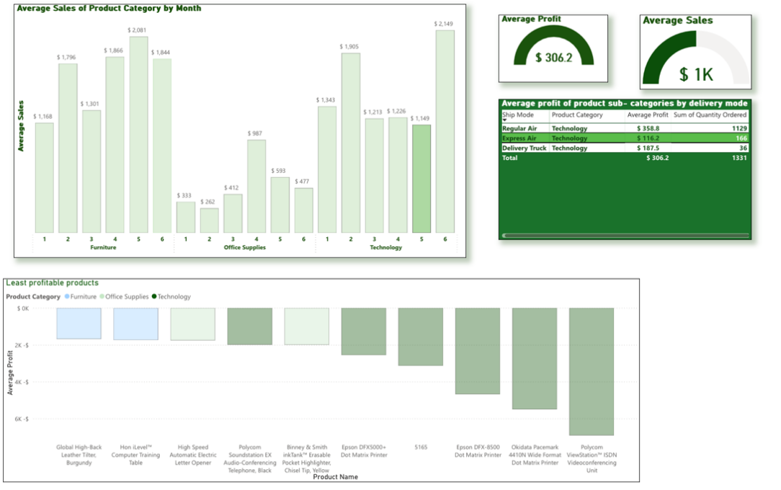

**(Figure: - 18-ii)**-Despite May having the lowest average sales in technological products it turned out to be the most profitable in comparison to other months. On average, May returned a profit of $306, where the most profitable and preferred mode of delivery was regular air.

We can conclude that Delivery trucks were on average the most profitable shipping mode for technological products and Furniture, Express air was only profitable for technological products because of the high profit margins per unit, and while office supplies may be cheaper than technological products, the consistent demand and lower shipping costs of regular air make it a viable and profitable delivery mode for this category. The top 10 least profitable products are also for your reference.

##### Assumptions :-

##### The dashboards target the Regional and Sales Managers. It is assumed that the Sales manager will have product knowledge, so that we can provide a deeper analysis of numbers of different products that would be meaningful.

##### The Regional Manager focuses merely on regional distributions and locations of products supply.

##### The Sales manager manages all the sales , profits of different products and sub-categories of products and is also assumed to have knowledge of all the product categories.

##### Deeper analysis can be further done in Power BI but has not been included due to word constraints of the task.

##### The months mapping has been performed in PowerBI i.e. Jan- 1 , Feb – 2 , Mar – 3 , Apr – 4 , May – 5 & Jun – 6.

# 5. JUSTIFICATIONs AND RECOMMENDATIONs

After performing our analysis on the dataset using Microsoft Excel and Power BI and creating the visualisations/dashboards above that have enabled the team to pinpoint the patterns, trends, and outliers in the dataset, we have produced five recommendations that may stimulate the growth of the business in the future.

##### 5.1 Recommendation based on Excel analysis :-

1. **Superstores is encouraged to apply more personalised marketing strategies for their customers in the south-eastern states, to cut their losses.**

It should be noted that there were numerous south-eastern states that generated a negative average profit. They were Florida, Arkansas, Mississippi, Alabama, Tennessee, Kentucky, Indiana, Virginia, North Carolina, Pennsylvania, and Connecticut. What is interesting to see is that all these states are clustered around the same geographic region, meaning that there could be common underlying reasons why the business experiences losses in this region.

A potential reason could be that many of these states have larger rural populations **(World Population Review 2020)**, so many workers may require different tools to do their jobs, in contrast to tools required in corporate environments, which Superstores specialises in selling. Another reason could be that the general advertising pitch in these regions just does not resonate with the consumers in this area. There is also a high variation in the amount of products that were ordered across these states, and we have discovered that the correlation between the total average profit of the region with respect to the number of products ordered is quite low.

Therefore, it may be a promising idea to engage in more personalised marketing across these lower performing areas to tailor particular products to the specific needs of an individual customer, rather than apply a broader strategy across these regions **(Suman Kumar 2014)**.

Advantages of personalised marketing are that businesses can increase customer satisfaction, engagement, and loyalty, leading to higher conversion rates and revenue, and with the right strategies and tools, Superstores can implement personalization effectively to gain their competitive advantage across these regions **(Jason Miller 2023)**.

However, Superstores will also need to be transparent about how they collect and use customer data and to obtain consent before using it for personalization purposes, to avoid legal issues which could be our major limitation**(Jason Miller 2023)**.

##### 5.2 Recommendation based ON POWER Bi report :-

1. **Superstores should allocate a larger portion of its budget to purchasing recyclable small box product containers.**

Doing this will prevent a substantial amount of financial/material wastage from occurring, assuming that the business is already purchasing too many larger boxes for packaging **(Sustainability Victoria 2023).** The larger boxes are used to package bulky items, such as Furniture and Technology, but they make up much smaller portions of the product categories that are sold, which are **20.04% and 23.42% respectively**, which reduces the necessity to have massive quantities of larger boxes on hand.

Furthermore, the top three most used product containers are small boxes, Wrap Bags and Small Packs. This makes sense, as the highest proportion of quantity ordered by product category is for office supplies **(56.54%)**, which are small, and hence would be shipped in smaller boxes. Finally, if Superstores were to ship their products to their customers by using sustainable packages, it would result in the following benefits.

Firstly, reducing environmental impact, since sustainable packaging materials often use less energy during production, and they can be derived from renewable sources. This aids in reducing the carbon footprint for Superstores, which in turn, will lead them to comply with any external regulatory requirements. Secondly, cost efficiency, as sustainable packages results in lighter packages being produced that are cheaper to transport and will reduce the cost of waste disposal. Lastly, an improved brand image that may cause a stronger emotional connection between the customers and Superstore’s brand, which creates customer loyalty. Smaller boxes make up the most substantial portion of product containers used by the business, so the business would be able to save a lot of money, as well as obtain a more environmentally friendly image, if it were to use recyclable smaller boxes, assuming that it is not already **(Vic Ning 2023).**

##### 5.3 Recommendation for Regional manager:-

1. **Reward customers in the most geographically profitable regions, as well as those who have ordered the most products.**

Across the six-month period, Superstores was operating across all the US states, and experienced a greater average profit in certain geographical locations compared to others.The top four best performing states were Rhode Island, Oregon, West Virginia, and the District of Colombia who all experienced an average profit above $500 for the duration of the period. It should also be noted that the number of products that were ordered in these states was considerably low in proportion to the profit they generated, and that these states are all relatively spaced out from one another (particularly Oregon), which indicates that there are a small portion of customers that were purchasing high margin products that were ultimately responsible for driving up the average profit in these regions.

Just like how Superstores can engage in personalised marketing to cut losses, it can also inversely be used to either maintain or further stimulate the interest of the customers located in these high profit regions. Furthermore, in addition to looking for customers that generate the most profit, the business can also pinpoint which customers order the most products. As we have already deduced above, the total number of products ordered across the six-month period is **25268.** The bulk of these products were standard office supplies which made up **56.64%** of the products that were ordered, where Paper, Pens & Art supplies and Binder accessories were the top 3 most frequent products ordered.

Superstores can track down the Top 10 Customers, that our team has helped identify above, and publicly reward them with gifts (as well as tag them on social media pages) that may include large quantities of these high turnover products (among others), in order to retain their loyalty, and provide other consumers (who may follow Superstores social media pages) with an incentive to purchase more Superstore products (**Louise O Brien and Charles Jones 1995).**

##### 5.4 Recommendation for Financial manager:-

1. **Superstores should review its shipping strategies and achieve product profitability by strategic pricing and minimize holding unprofitable products as inventory.**

We have seen in the financial dashboard that in certain months some delivery modes are unprofitable. Superstores may want to review shipping strategies by focusing on optimizing logistics and transportation routes to reduce shipping costs, which will then increase the profit margin. As different product categories perform better in specific months, it would be possible to leverage product distribution and increase discounts, which will then lead to more quantities ordered and eventually increase sales and profits. Implementing strategies such as increasing shipping costs for prioritized products and consolidating it into a single mode of delivery for most products can potentially lead to increased profits. Furthermore, removing unprofitable products and optimizing inventory will not only reduce the number of products and increase the product quality but it will also help in focusing on the most profitable and preferred products only. By implementing these recommendations, the financial manager can drive meaningful improvements and sustain the success of superstores in the market. **(Cogsy May 18, 2022).**

##### 5.5 BONUS RECOMMENDATION FOR THE FINANCIAL MANAGer

# References

Dr Shekar Pawar (2016), 5 Powerful Benefits of Excel <<https://www.linkedin.com/pulse/5-powerful-benefits-excel-shekhar-pawar/>>

Is Your Inventory Killing Your Profits? [& How To Fix It]. (n.d.). Cogsy.

<https://cogsy.com/blog/is-your-inventory-killing-profits/>

Jason Miller (2023), The benefits of personalisation in Digital Marketing, <https://www.linkedin.com/pulse/benefits-personalization-digital-marketing-jason-miller/>

Leighton Murdock (2024), How can you use discounts and coupons to effectively drive sales? <https://www.linkedin.com/advice/0/how-can-you-use-discounts-coupons-effectively-drive-lw9je#:~:text=Coupons%20and%20discounts%20can%20be,of%20missing%20out%20(FOMO)>**.**

Louise O Brien and Charles Jones (1995), Do Rewards really create loyalty? <https://hbr.org/1995/05/do-rewards-really-create-loyalty>

Muhammad Sheheryar (2023), Excel Tables: Are they worth it? Weighing Pros and Cons <https://www.linkedin.com/pulse/excel-tables-worth-weighing-pros-cons-muhammad-sheheryar/>

Marquette University (2024), Removing Hidden Data in Microsoft Excel <https://www.marquette.edu/its/help/security/hiddenexcel.shtml#:~:text=Avoid%20unintentionally%20distributing%20hidden%20information,worksheets%2C%20by%20removing%20hidden%20data>

Nancy J (2023), 5 Top Advantages of Power BI Training for Business Intelligence <https://www.linkedin.com/pulse/5-top-advantages-power-bi-training-business-intelligence-nancy-j-r9mwc/>

Rahm, Erhard & Do, Hong. (2000). Data Cleaning: Problems and Current Approaches. IEEE Data, Eng.Bull.23.3-13 <https://www.researchgate.net/publication/220282831_Data_Cleaning_Problems_and_Current_Approaches>>

Suman Kumar Dawn (2014), Personalised Marketing: Concepts and Framework, Vol. 54, Issue. 4, (Jan-Mar 2014): 370-377., <https://www.proquest.com/docview/1516358681?pq-origsite=gscholar&fromopenview=true&sourcetype=Scholarly%20Journals>

Sustainability Victoria (2023), Accepting reusables at your business, <https://www.sustainability.vic.gov.au/recycling-and-reducing-waste/in-a-business-2/single-use-plastics-ban-centre/accepting-reusables-at-your-business>

Vaibhav Lambat (2024), How do you manage Duplicate Data Records. <https://www.linkedin.com/advice/1/how-do-you-manage-duplicate-data-records-skills-data-analysis#:~:text=Duplicate%20data%20records%20are%20a,to%20erroneous%20conclusions%20or%20decisions>

Vic Ning (2023), Top 5 Benefits of Sustainable Packaging in your Business, <https://www.linkedin.com/pulse/top-5-benefits-sustainable-packaging-your-business-vic-ning-rperc/>

World Population Review (2020), Most Rural States 2024. <https://worldpopulationreview.com/state-rankings/most-rural-states>